Hart Local Party – Council Reports for AGM 8th November 1924

Hampshire County Council – Adrian Collett
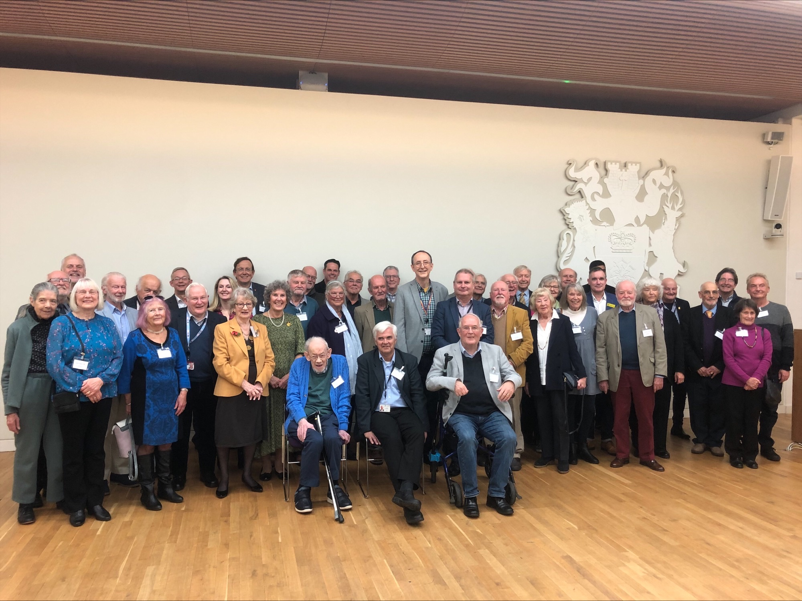
The finance crisis at Hampshire County Council is deepening fast, following years of financial incompetence by the Conservatives at both Hampshire and Government levels. A £132 million recurring budget deficit by April 2026 has now increased to £175 million, and is expected to worsen still. With County Council elections coming up next May, the Tories decided not to go ahead with their most controversial service cuts. So Household Waste Recycling Centres and School Crossing Patrols are saved for now, but what will happen if the Tories were to hold onto power next year? Will those services go once the elections are safely over?
One of the most visible impacts of the budget cuts is the state of our roads. Not just potholes, but road signs too dirty to read, or hidden behind branches which have not been cut back. The good news is that they are not cutting the pothole filling budget. Instead they are cutting the pothole prevention budget by £7.5 million. Unbelievable, but true!
Liberal Democrats are looking forward to making significant gains on Hampshire next May. Either to reduce the Tories so they no longer have an overall majority or, even better to achieve a Lib Dem majority. It will take time to sort out the Tory mess, but we have plenty of ideas of what can be done better to achieve this.
Finally, the Lib Dem County Councillors' Reunion went ahead last year with a high turnout. See the attached photo. There are three past or present Hart Lib Dem County Councillors in the photo. See if you can spot them Don't give any clues David!

Hart District Council - Dave Neighbour

​In February we passed a budget which invested an additional £400k to frontline services, whilst keeping Council Tax down to a 2.99% increase. In May, we held all 4 seats we were defending as well as gaining the last seat in Fleet East. This makes us the largest group on HDC with 12 councillors.

This Summer, we delivered £1million of central grant through the UK Shared Prosperity Fund to 16 projects throughout the district. We continue to prioritise Climate Change by installing more EV charging points (Fleet, Hook and Odiham) as well as introducing HVO fuel to our refuse fleet.

In terms of the cost of living crisis we are delivering a second year of Winter Pressures Grants.

Blackwater and Hawley 2024 Achievements – Daisy Khepar

Leisure Centre
The UK Shared Prosperity Grant funding is being put to good use and the kitchen in the main hall is under construction with a replacement ceiling, new units, new sink and flooring. We have new LED lighting and new fuse box. We have also installed different storage cupboards for various groups to store equipment in. The grant has helped us to become more of a community hub. This work should be completed soon. By the way if you are looking for squash courts in the area then come down to our leisure centre and book. Our squash courts are very popular We also hope to have a Sauna up and running very soon.

Memorial Hall
Work to the stage and lighting for the Hart Players has taken place at speed, a new lighting bar has been installed together with electrics, the stage is now a real ‘black box’ and rehearsals are taking place. Tickets are available to purchase on-line for their production of Abigail’s Party and also the Comedy Night on 15th November.

In addition to the Hart Players and Comedy Night, there are a couple of functions booked before the end of the year. We have new groups signing up.e.g. Irish Dancing, Hula hoop exercises and Amateur dramatics.

The coffee shop and the Inn on the green are slowly becoming more and more popular. I personal recommend the Lemon drizzle cake if you are ever in the area. Now with the football season we also serve sausage and bacon baps.
All staff are throwing their energy into drawing up plans for the kitchen/counter refurbishment and currently there are many ideas. We have settled on a menu and talks are on-going with various companies for designs and quotation.
The Bar is very popular in the summer as we put up a marques and seating for cricket spectators or walkers. In the winter months it is decorated for Halloween as well as later for Christmas

Out door Pitches are now maintained inhouse so we have invested in new equipment for our groundsmen to do that mor efficiently.

The Cemetery maintained by the council has also had some work done. The trees surrounding it had overgrown and were looking unsightly. Also, some people complained that the roots were damaging the graves of their loved ones. Hence, we took the decision to cut the trees down. They will be replaced by native hedging by the spring of next year!!

Fleet Town Council – Dan Taylor

Fleet Town Council has been active recently with community events, staff changes, and several awards in the In Bloom competition. We welcomed a new Clerk and a new press officer, and two additional Councillors have been co-opted, leaving one vacancy. The council is dedicated to enhancing its communications, which includes a redesigned newsletter and social media posts highlighting the positive contributions in our community, along with new bios for our Councillors. As part of this communication overhaul, a new website will be launching soon.

Key Updates
- Harlington Refurbishment Project continues but at a slow pace. The rigorous architect selection process was completed but the ongoing negotiations on the long-term lease arrangement with Hart District Council continues. Once the lease is signed the architect can be appointed and the much-needed multi-million-pound project can commence.
- 2025/26 Budget work has started. Many of the playparks that were purchased with S106 money are now reaching end of life and will need extensive repairs or replacements over the next year which is likely to put huge challenges on the budget. With general reserves (excluding Harlington fund) at a low level the precept may need to be raised again to hold services constant.
- Greening Fleet project has already produced some excellent results. There is now a regular repair café providing people with somewhere to get broken household items fixed. The creation of nature corridors are being planned across the Town and there are regular litter picks ongoing.
- Increased levels of vandalism in Calthorpe park has led to the removal of some play equipment.
- The Cemetery continues to be inhabited by badgers at great cost to the council. The cemetery is almost at capacity for burials and options are being investigated.
Events
- Music on the Views This new festival held at the end of August was enjoyed by many and due to its success will be returning next year.
- Fleet Repair Café runs every month with the next on 2nd November
- Remembrance Day 10th November
- Councillor coffee morning 23rd November 10:30am
- Christmas Festival & lights switch on: 27th November 2pm – 9pm

Hartley Wintney Report - Deborah Fontana

The Auditors for The Parish Council have strongly advised that HWPC increase the Council Budget for 2025/2026 by at least £120,000. This will enable HWPC to continue providing services and protect current and future assets. So in principle HWPC will increase the precept from £340,323 to £464.206. So a band D property will increase by £168.62 a year or £3.24 per week. Services HW can continue to enjoy are: Community Bus, Play Grounds,Public Toilets, Ponds and open space, Allotments, Lucy Pygott centre & Burial Grounds.
The Full Council are in communication in regard to The Monachus Lane 90min Free vend parking in the Red Bays. We are now in discussion that the Red bays will no longer be free but charged at .20p an hour like Fleet?
It was agreed after much resistance from Cllrs there would now be a Working group in regard to The HW Flooding this year. Myself, Cllr Michael Fox and Cllr Steve Airton will be the only Cllrs on this, as there was little interest. The thought in the room was that HW has always flooded and a working group would not solve anything!
Thames Water A30 road works will continue with no date available on an end date, but will be sometime after Christmas or New Year!!
Resurfacing at the controlled Junction on the A30 between Dilly Lane and Thackhams Lane.
Constant complaints about the speed of traffic on the Fleet Road, residents want the 30 mph limit to be extended to the Riffle Range. Mitchell Avenue and Green Lane complaints of speeding. Looking into 20s plenty or like Vicarage hill where bollards are now in place to stop through and speeding traffic
HW have been waiting two years for SIDs - Speed indicator advice.
Winchfield to Hook trainline possible weekend closures for 5 weekends in the new years
Last but not least! Hartley Wintney Recycling Centre remains open, which Conservatives tried to take credit for (Of Course)! I will be keeping the pressure on The Conservatives and be attending Full Parish Council Meetings across the Division.

Hook Parish Council Report – Shamraz Razzaq

Largest and most pressing issue is the Pavillion. We finally received planning permission from HDC following a longer than expected delay. The committee is expecting to release tender before Christmas but questions remain on understanding what is it we’re buying and the impact on budget. There seems to be little appetite to delay the project and we have a serious shortage of Project Management skills on the council.
A lot of tree work has been done following recent weather conditions. Funding this is not an issue as SANG fund is considerable. Work is underway to see if this fund can be used for other green initiatives.
Work continues with HCC to reduce speed limits north and east of Hook where development has occurred but speed limits remain above 30mph.
My work continues to make all playgrounds in Hook accessible and plans are being put in place for changes over the next few years as and when equipment comes up for replacement.
Work on next years budget is underway. Initial view is there will potentially be increases in HPC precepts.
HPC still has one Councillor vacancy remaining.

Yateley, Frogmore and Darby Green Town Council Report – Pam Phelps-Jones

Climate change
- Continued work to reduce the Town Council’s carbon footprint by improving energy efficiency in council buildings with improved insulation, installation of hive heating and work towards acquiring solar panels.
- TC Staff have completed Carbon Literacy Qualifications.
- Disease resistant elms and sweet and horse chestnut trees were planted on Yateley Green and Frogmore Green.
- A Climate Change Officer has been recruited and started working on updating the town action plan to reach net carbon zero by 2030.
Updates
- The town logo and strap line to include the whole parish.
- Work on town cemetery benches has been done with sensitivity and care.
- Refurbishment of the town war memorial plus, in partnership with the British Legion and members of the community, a poppy cascade has been crafted.
- The Covid Snake (Covid memorial) the stones are now all varnished and ready to be fixed in to place at the cemetery, which should be soon. A plaque has been designed to go alongside it; explaining its history.
- Tennis courts have been cleaned, renovated and new automatic gate and booking system put in place.
- Town newsletters were delivered to every household in the parish.
Accessibility
- An accessible path has been installed from the Reading Road into the Yateley Green car park.
- Two new accessible picnic benches will be installed at Monteagle Open Space along with an upgrade to the path between the Orchard Hall and play area to enable better access by wheelchair users.
Town Events
- A well attended Annual Town Meeting was held with presentation by the mayor of certificates of recognition for individuals and organisations that do so much to support our community.
- The Feel Good Festival had its first event in September. This gives the parish a bookend of festivals in Spring and Autumn.
- D Day memorial beacon was lit.

end

